PHASE 6
Project Testing
Test Cases
ID | Test Case | Input | Expected Output | Actual Output | Result
TC01 | Register API | Valid name, email, password | User created, 201 response | As expected | Pass
TC02 | Login API | Valid registered email & password | JWT token returned, 200 response | As expected | Pass
TC03 | Login API | Invalid password | 401 Unauthorized error | As expected | Pass
TC04 | Topic API | Valid subject, topic title, notes + JWT | Topic created, 201 response | As expected | Pass
TC05 | AI Study Aid API | Valid topic notes + JWT | AI-generated summary & study recommendation returned | As expected | Pass
TC06 | Topic CRUD | Add/Update/Delete study topic | Topic persisted/updated/removed correctly | As expected | Pass

Bugs Found and Fixes
Bug | Fix
Missing token returned 500 instead of 401 | Added explicit check in auth middleware to return 401 when no token is supplied
Duplicate email allowed on registration | Added unique index and pre-save validation on the email field
AI service failure crashed the request | Wrapped Gemini AI call in try/catch with a graceful fallback response

Final Testing Screenshots
Register API
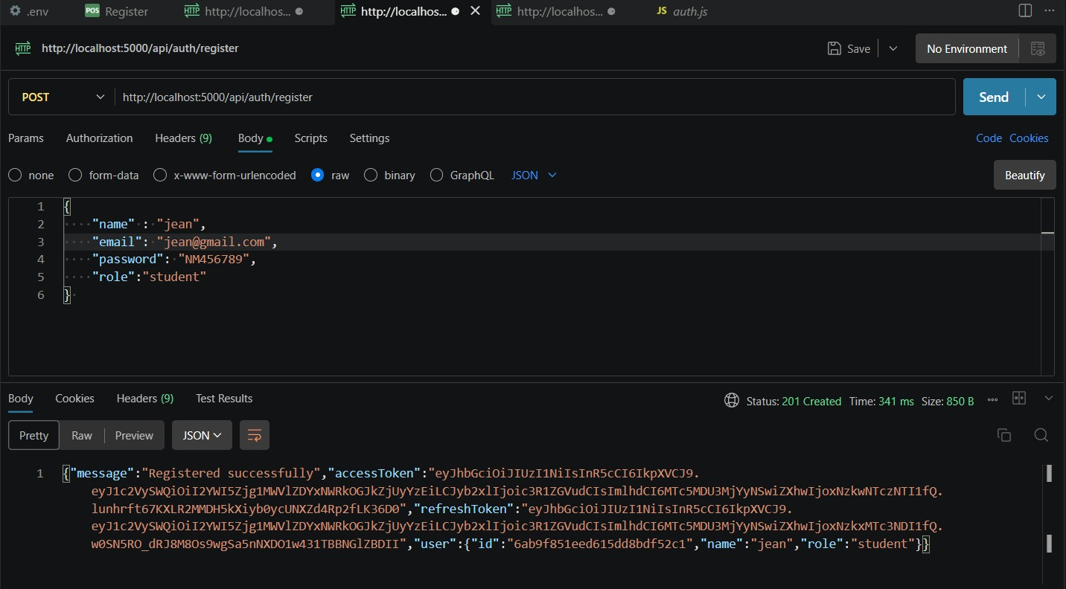
Fig 6.1 – Register API tested in Postman
Login API
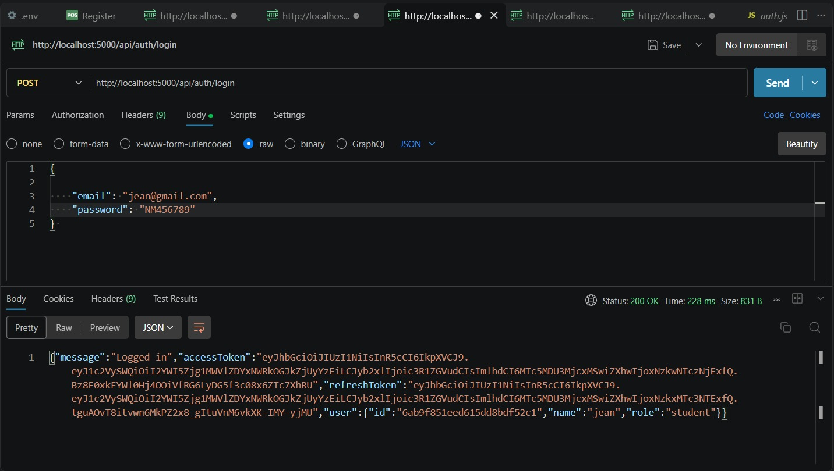
Fig 6.2 – Login API tested in Postman
Logout API
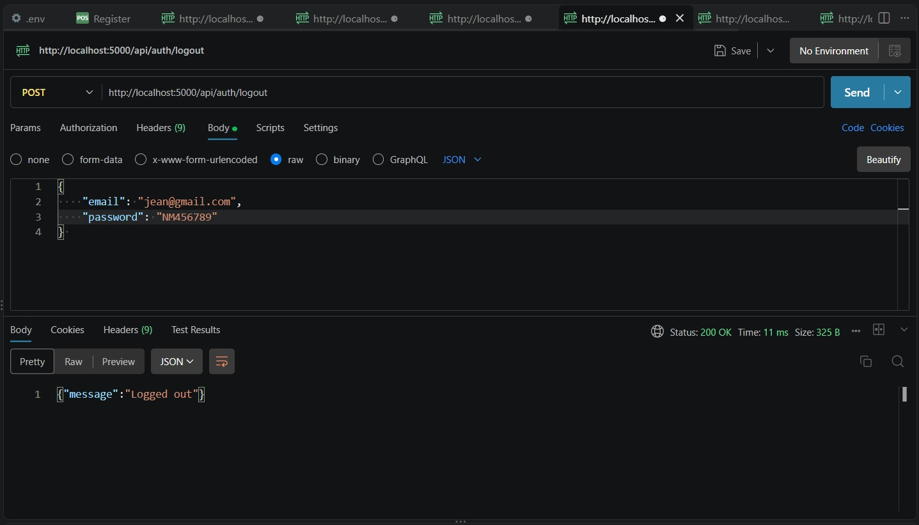
Fig 6.3 – Logout API tested in Postman
Admin – Get All Users API
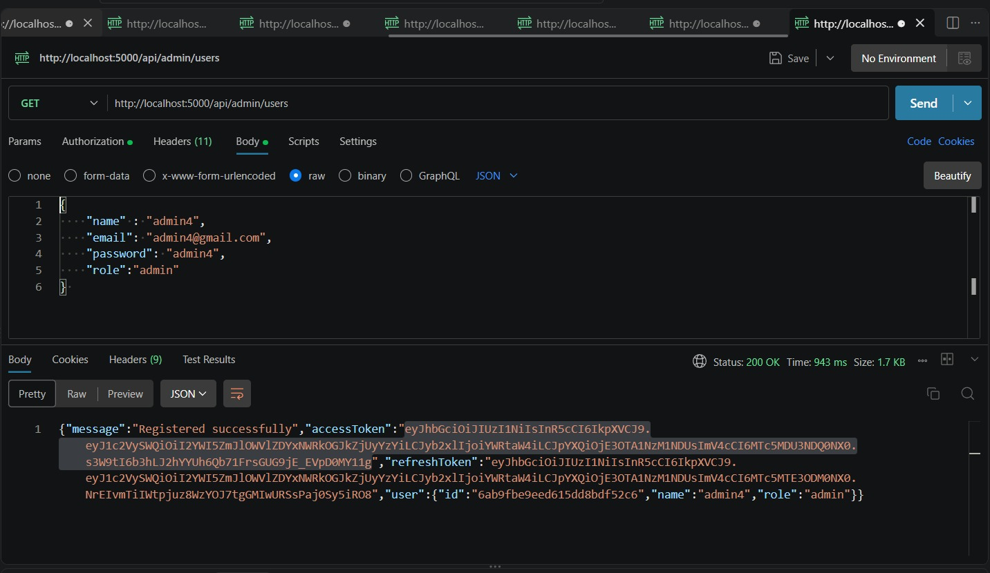
Fig 6.4 – Admin Get All Users API tested in Postman
Admin – Delete User API
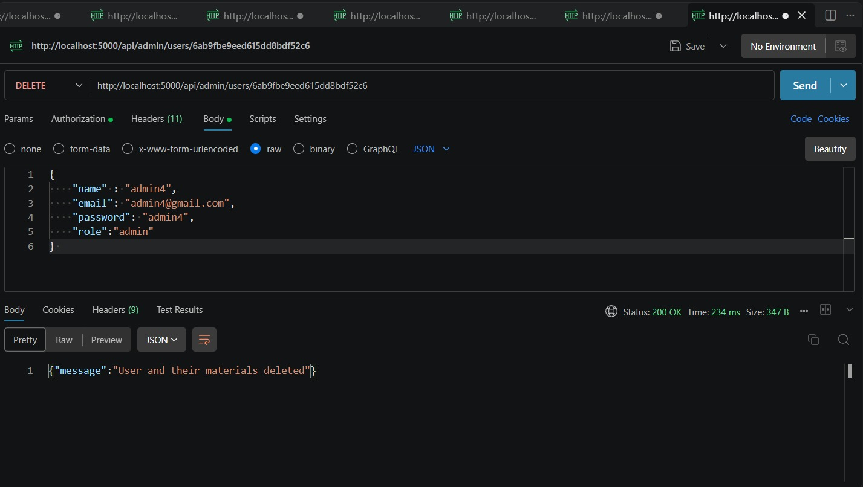
Fig 6.5 – Admin Delete User API tested in Postman
Server Running
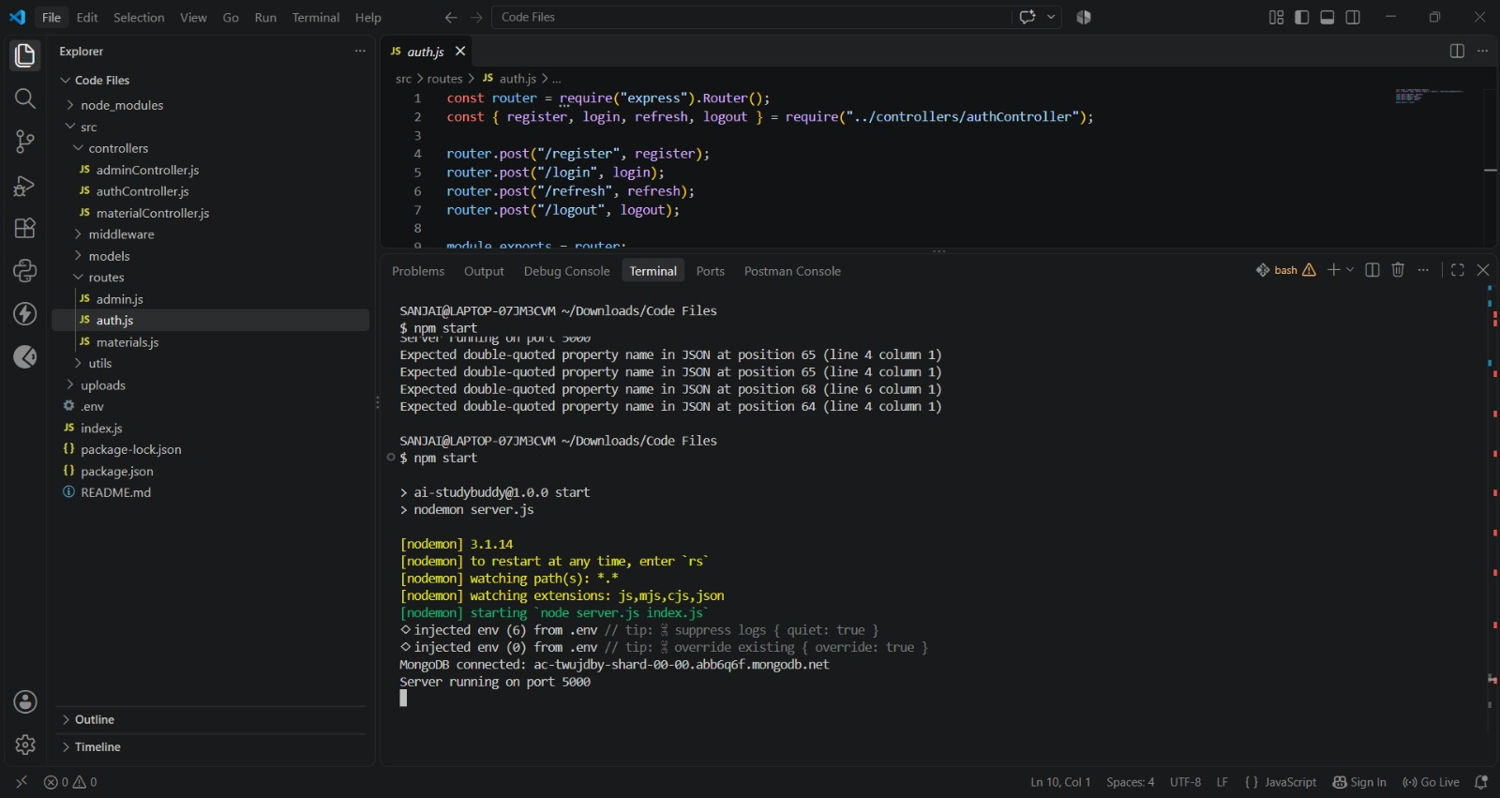
Fig 6.6 – Server running and connected to MongoDB

